# Lab: Objects, Classes and Collections

This document defines the exercises for ["Java Advanced" course @ Software University](https://softuni.bg/courses/java-advanced). Please submit your solutions (source code) of all below described problems in [Judge](https://judge.softuni.bg/Contests/781).

# Stacks

## Matching Brackets

We are given an **arithmetical expression** with **brackets**. Scan through the string and extract each **sub-expression**.

Print the each sub-expression on a new line.

### Examples

|  |  |
| --- | --- |
| **Input** | **Output** |
| 1 + (2 - (2 + 3) * 4 / (3 + 1)) * 5 | (2 + 3)  (3 + 1)  (2 - (2 + 3) * 4 / (3 + 1)) |
| (2 + 3) - (2 + 3) | (2 + 3)  (2 + 3) |

### Hints

* Use a stack, namely an **ArrayDeque()**
* Scan through the expression searching for brackets
  + If you find an opening bracket, push the index into the stack
  + If you find a closing bracket pop the topmost element from the stack. This is the index of the opening bracket.
  + Use the current and the popped index to extract the sub-expression

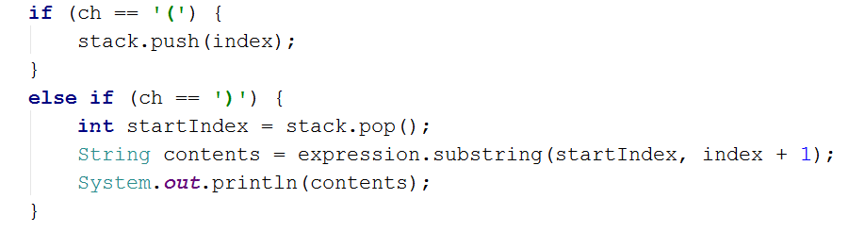

# Queues

## Hot Potato

Hot potato is a game in which children in a circle start passing a hot potato. The counting starts with the fist kid. **Every nth time the child left with the potato leaves the game**. When a kid leaves the game, it passes the potato **forward**. This continues repeating **until there is only one kid left**.

Create a program that simulates the game of Hot Potato. **Print every kid that is removed from the circle**. In the end, **print the kid that is left last**.

On the first line you will get the **children names** and on the second – the integer **n**.

### Examples

|  |  |
| --- | --- |
| **Input** | **Output** |
| Mimi Pepi Toshko  2 | Removed Pepi  Removed Mimi  Last is Toshko |
| Gosho Pesho Misho Stefan Krasi  10 | Removed Krasi  Removed Pesho  Removed Misho  Removed Gosho  Last is Stefan |
| Gosho Pesho Misho Stefan Krasi  1 | Removed Gosho  Removed Pesho  Removed Misho  Removed Stefan  Last is Krasi |

## Math Potato

Rework the previous problem so that a **child is removed only on a prime cycle** (cycles start from 1)

If a **cycle is not prime**, just **print the child's name.**

As before, print the name of the child that is left last.

### Examples

|  |  |
| --- | --- |
| **Input** | **Output** |
| Mimi Pepi Toshko  2 | Removed Pepi  Prime Mimi  Prime Toshko  Removed Mimi  Last is Toshko |
| Gosho Pesho Misho Stefan Krasi  10 | Removed Krasi  Prime Pesho  Prime Misho  Removed Stefan  Prime Gosho  Removed Gosho  Prime Misho  Removed Pesho  Last is Misho |

# Sets

## Parking Lot

Write program that:

* Records a **car number** for every car that enters a **parking lot**
* Removes a **car number** when a car goes out

The input will be a string in format **[direction, carNumber]** and ends with the string **"END"**

Print the all car numbers which are in the parking lot at the end.

The order of the output does not matter.

#### Examples

|  |  |
| --- | --- |
| **Input** | **Output** |
| IN, CA2844AA  IN, CA1234TA  OUT, CA2844AA  IN, CA9999TT  IN, CA2866HI  OUT, CA1234TA  IN, CA2844AA  OUT, CA2866HI  IN, CA9876HH  IN, CA2822UU  END | CA2822UU  CA2844AA  CA9999TT  CA9876HH |
| IN, CA2844AA  IN, CA1234TA  OUT, CA2844AA  OUT, CA1234TA  END | Parking Lot is Empty |

#### Hints

* Car numbers are **unique**
* Use the methods **isEmpty()**

#### Solution

You might help yourself with the code below:

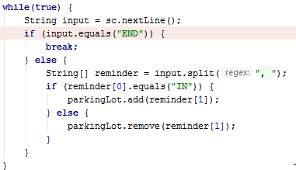

## SoftUni Party

There is a party in SoftUni. Many guests are invited and they are of two types - **VIP** and **regular**. You will get a reservation list with all invited guests. When a guest comes, check if he/she exists in the reservation list. **All** reservation numbers will consist of **8 chars**. All **VIP** numbers **start with a digit**.

There will be 2 command lines:

* "PARTY" – the party is on and guests start coming.
* "END" – the party is over and no more guest will come.

#### Output

* On the first line, print how many guests didn't show up
* On the lines after that print their reservation numbers
* First, print all VIP guests in order of their appearance and after that print the regular guests

#### Hints

* Use **TreeMap<>()**

#### Examples

|  |  |  |  |
| --- | --- | --- | --- |
| **Input** | **Output** | **Input** | **Output** |
| 7IK9Yo0h  9NoBUajQ  Ce8vwPmE  SVQXQCbc  tSzE5t0p  PARTY  9NoBUajQ  Ce8vwPmE  SVQXQCbc  END | 2  7IK9Yo0h  tSzE5t0p | 2FQZT3uC  dziNz78I  fPXNHpm1  HTTbwRmM  xys2FYzn  MDzcM9ZK  PARTY  2FQZT3uC  dziNz78I  fPXNHpm1  HTTbwRmM  END | 2  MDzcM9ZK  xys2FYzn |

# Maps

## Academy Graduation

Write a program that reads students with their **names** and **scores** for different courses. Afterwards print the average score of every student in the following format: “**{Students name}** is graduated with **{average score)**”

The order of the output does not matter.

#### Examples

|  |  |
| --- | --- |
| **Input** | **Output** |
| 3  Gosho  3.75 5  Mara  4.25 6  Pesho  6 4.5 | Gosho is graduated with 4.375  Mara is graduated with 5.125  Pesho is graduated with 5.25 |
| 5  Gruio  4.36 5.50 3.30 5.63 2.57 5.75 2.81 4.89  Trendafilka  3.10 5.35 3.30 3.35 5.64 4.99 2.75 4.68  Mite  3.45 3.23 3.03 5.42 5.46 4.15 2.26 5.95  Roza  2.08 3.48 3.36 2.73 2.96 4.54 3.70 3.85  Ganio  4.75 4.92 3.78 4.79 4.82 4.75 2.81 2.13 | Ganio is graduated with 4.09375  Gruio is graduated with 4.351249999999999  Mite is graduated with 4.11875  Roza is graduated with 3.3375  Trendafilka is graduated with 4.145 |

#### Hints

* Think about a **proper type** of map
* **Values** can be stored into an **array**